IPL zVM from HMC  
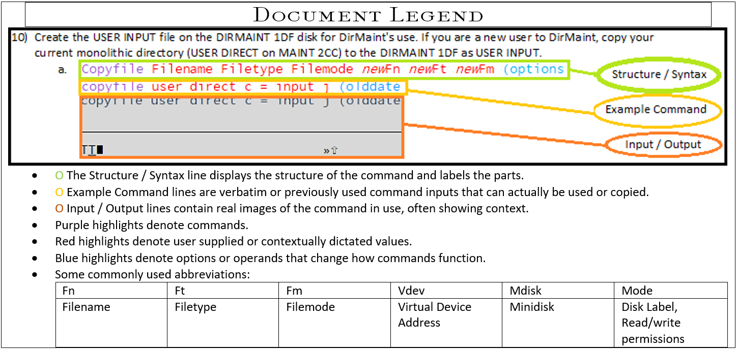

1. From the HMC select the System and *Load* from the *Recovery* menu to start up the newly installed system from the newly installed files!
   1. Select ***Load*:**System>Recovery>Load  
      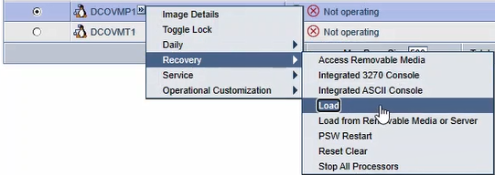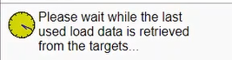
   2. **Select** <*OK*> to Load (from the Residence volume where the install files reside as shown)  
      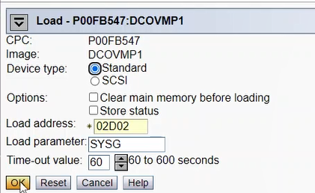
   3. **Select** <*Yes*> to confirm the Load Task is desired.  
      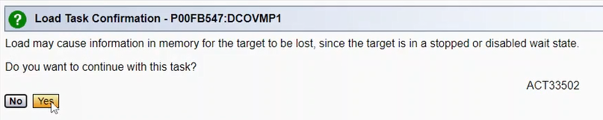
   4. **Input** HMC user password and **Select** *<Yes>* to authorize the confirmed request and acknowledge the warning.  
      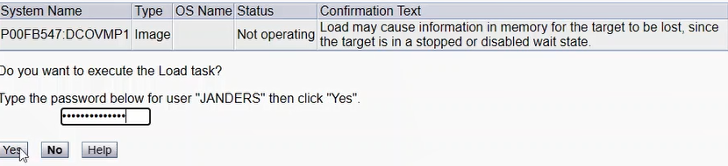
   5. Allow the task to load and after the Status is Success **Click** *<OK>*.  
      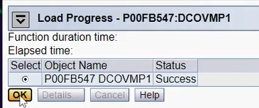

Allow a few moments to pass for the IPL to complete then refresh the HMC page to confirm the system is Operating status and the correct OS information displays.